Paula De Francisco Pérez  Performance & Paid Social · Q-Commerce · AI-First  Dubai, UAE | +971 50 386 3656 | paulich98@hotmail.com  linkedin.com/in/paula-de-francisco-perez-92a13119a  Portfolio: paula-de-francisco.vercel.app  Nationality: Spanish | UAE Employment Visa (employer-sponsored) | 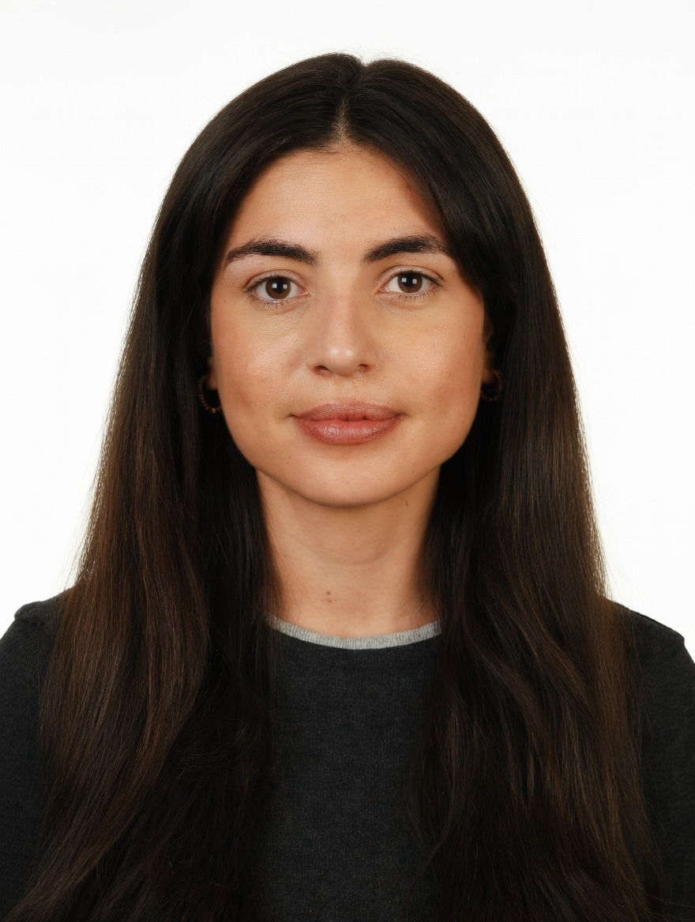
PROFESSIONAL SUMMARY

Performance-minded marketer with 5 years across e-commerce and quick-commerce (Glovo, Alibaba's Miravia, DoFreeze). In Dubai, runs Meta and Google Ads for brands sold on talabat, Noon and Careem and measures campaigns on incremental sales against a control. AI-first: automates planning, content and reporting with Claude (~40% less manual work).
WORK EXPERIENCE

Brand & Marketing Manager | Oct 2025 – Present
DoFreeze LLC · UAE F&B / FMCG group | 7 brands incl. Befit, Eurocake, SMASH | sold on talabat, Noon, Careem · Dubai, UAE
• Run paid social and search on Meta and Google Ads: built an Advantage+ catalogue retargeting campaign at 3.7x ROAS and AED 34.5 per purchase in week one; August account at 829K impressions, 2.01% CTR, AED 4.64 CPM
• Allocate budget across brands and channels on break-even ROAS net of marketplace commissions; moved Google spend to Meta when its return did not cover the cost
• Measure incrementality, not last touch: SMASH x talabat lifted daily sales +165% vs +4.7% for a control brand; Befit x Noon added 4,176 incremental units (+31% vs baseline)
• Run weekly creative-hook tests across 4 social accounts and brief a designer and a social media exec on short-form video; a SMASH giveaway added followers at AED 0.73 each, 8x cheaper than a promoted reel
• Built the influencer programme from zero: 103 creator activations over 3 waves at AED 81 per content piece; negotiated −30% and audited the agency's reach reporting
• Web orders +86% and revenue +57% (Q1 vs Jun–Aug 2026) after adding reviews, basket-based bundles and a 30-day replenishment flow; landing pages built with AI agents
Key Account Manager – Beauty, Fragrances & Fashion | Nov 2023 – Oct 2025
Miravia & AliExpress (Alibaba Group) · Beauty & Health department · Madrid, Spain
• Grew 42 beauty and fragrance brands (incl. L'Oréal Paris, Maybelline, NYX, Redken, KIKO Milano) +30% GMV QoQ through pricing, promotions and on-site visibility; worked with marketing, product and ops
• Owned Flash Sales (up to ~30% of B&H sales), reporting to the CEO; grew Arabian perfume into a top-growing sub-category
Account Manager – XL Accounts | Sep 2022 – Nov 2023
Glovo · Food & quick-commerce delivery app | 10K+ employees · Madrid, Spain
• Co-managed 5 XL restaurant accounts (KFC, Taco Bell, Vicio) on GMV, orders, promo spend and in-app ads; read campaign returns to pick activation days; weekly refund-fraud reviews
Early Career | 2019 – 2022
Mondelez International · Línea Directa Aseguradora · Global FMCG | Spanish direct insurer · Madrid, Spain
• Category Planning Trainee, Mondelez (Aug 2021 – Aug 2022): sell-in/sell-out and promo-effectiveness analysis, NPD support
• Accounting Intern, Línea Directa (Jan – Dec 2019): accounting department of an insurer, working in SAP and Looker
CORE SKILLS & TOOLS

Paid Media | Meta Ads (Advantage+, catalogue retargeting), Google Ads, budget allocation, creative testing
Q-Commerce & E-Com | talabat, Noon, Careem, Amazon, Glovo, Miravia, AliExpress, Shopify, CRO, email segmentation
Measurement | incrementality vs control, break-even ROAS, ROAS, CPA, CPM, CTR, promo uplift, KPI reporting
Data & Analytics | Excel (Expert), Looker, Power BI, SAP, Meta Ads reporting, Shopify analytics
AI & Tools | Claude / Claude Code (workflow automation), ChatGPT, prompt engineering, Canva, Photoshop
EDUCATION

Bachelor's in Business Administration — CUNEF Universidad, Madrid | 2016 – 2020
Specialisation: E-Commerce · Fashion Industry · Thesis on e-commerce in fashion retail (9.5/10)
Google E-Commerce Certificate · Google Digital Marketing Certificate
LANGUAGES

Spanish | Native | English | Professional C1

